

Programing of Computer Games

Name | Course Title | Date

# Question 1

1. The 2 game engines are Unity and Unreal Engine. Unity engine can be easily understand and runs faster. There is a large community with active forums that can help you solve any questions. Unity can easily integrate on each cross-platform. It can be downloaded free and don’t have to pay for a license.
2. The 2 programming languages are C# and Java. C# it is a portable executable file that can contain any number of classes. It combines the productivity of Visual Basic and the raw power of C++. It is Object Oriented since objects in java are now structures in C#. The classes in C# are grouped in Namespaces.

# Question 2

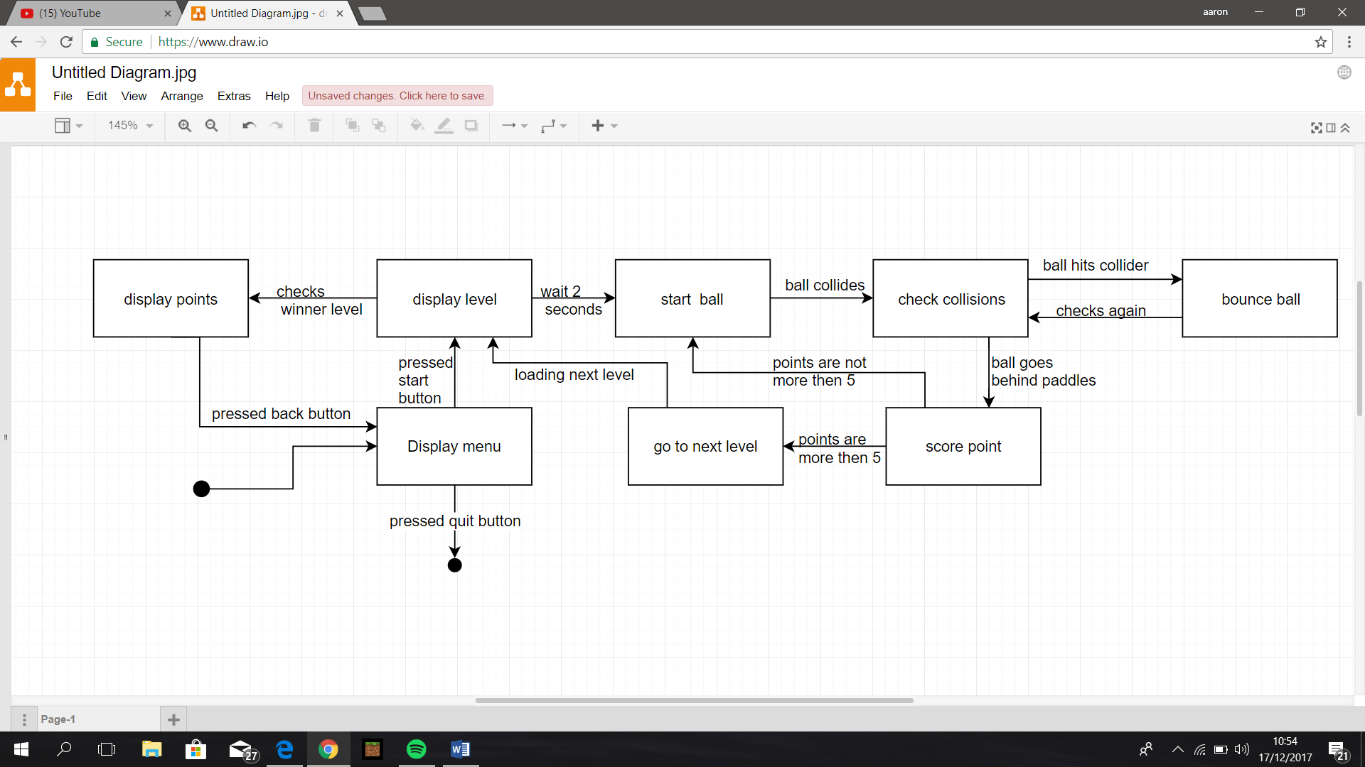A)

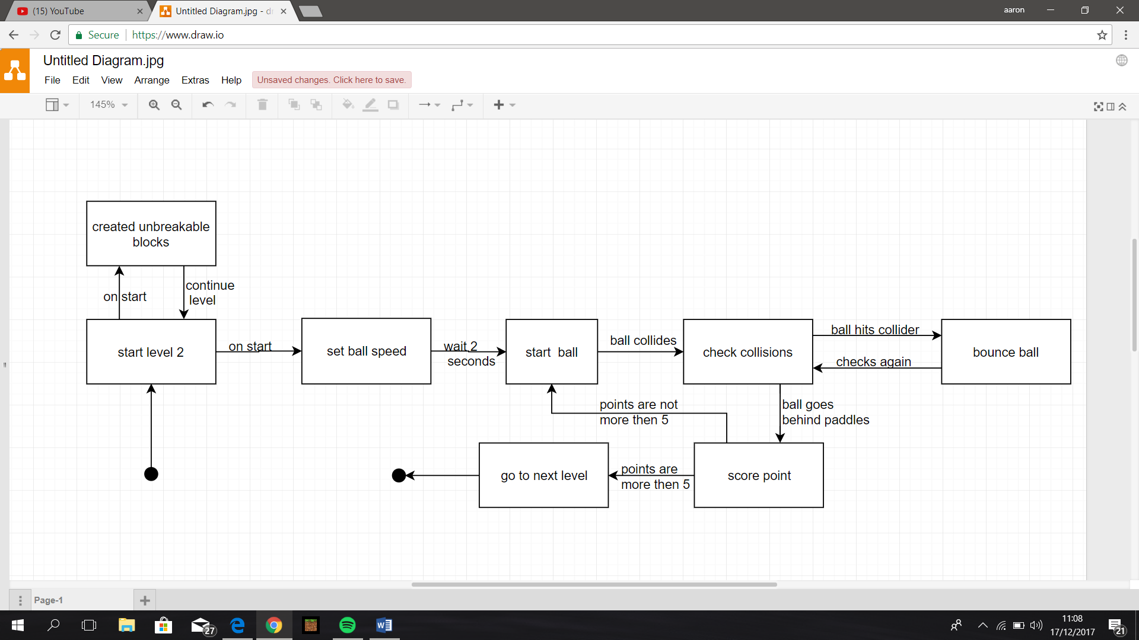B)

# Question 3

When you have a compressed media asset, it is easier and faster to download the asset since it will be in smaller data. This way it will help you to store more data in your device since it will be compressed. Compressed media is a normal media, but its data is compressed in such a way that it removes the unwanted data, it is like having a bag and you are removing the air from it. But when you are going to access asset you must remove it from a compressed media. So, it is better to compress your media asset when you are uploading a file so that it is easier to download and it will upload much more faster.

# References

C-sharpcorner.com, 2017. *Top 10 Most Important Features Of C#.* [Online]   
Available at: http://www.c-sharpcorner.com/article/top-10-most-important-features-of-C-Sharp-programming/  
[Accessed 12 12 2017].

Definline.com, 2017. *Unity Game Engine vs. Unreal Engine: pros and cons.* [Online]   
Available at: https://definline.com/unity-vs-unreal-pros-cons/  
[Accessed 11 12 2017].

HowStuffWorks, 2017. *How File Compression Works.* [Online]   
Available at: https://computer.howstuffworks.com/file-compression.htm  
[Accessed 14 12 2017].